Coca-Cola HBC Policy to Tackle Food Loss

1. Our commitments
The food & beverage industry in Europe is part of a joint declaration on food wastage, Every Crumb Counts with the commitment to prevent edible food loss, to promote a life-cycle approach to reducing wastage and to proactively feed into European, national, and global solutions and initiatives in this area. Besides, the ambition is to create more awareness of the need to reduce food loss within own operations and along the entire value chain. Eventually, signatories pledge to collaborate across all stakeholder groups and to contribute to the development and dissemination of best practices.
Coca-Cola HBC supports all relevant aspects of this declaration, which directly contributes to our zero waste-to-landfill target.
2. Causes of food loss and our holistic focus across the value chain
We apply a holistic approach in tackling the loss of our beverages and the ingredients we use caused by quality non-conformity, spillage, breakages, or storage beyond expiry date. For that purpose, we focus on all steps of our value chain, and we measure food loss in ingredients, manufacturing, warehouses & distribution or at customer level, and we analyze the potential of food loss per type and category:
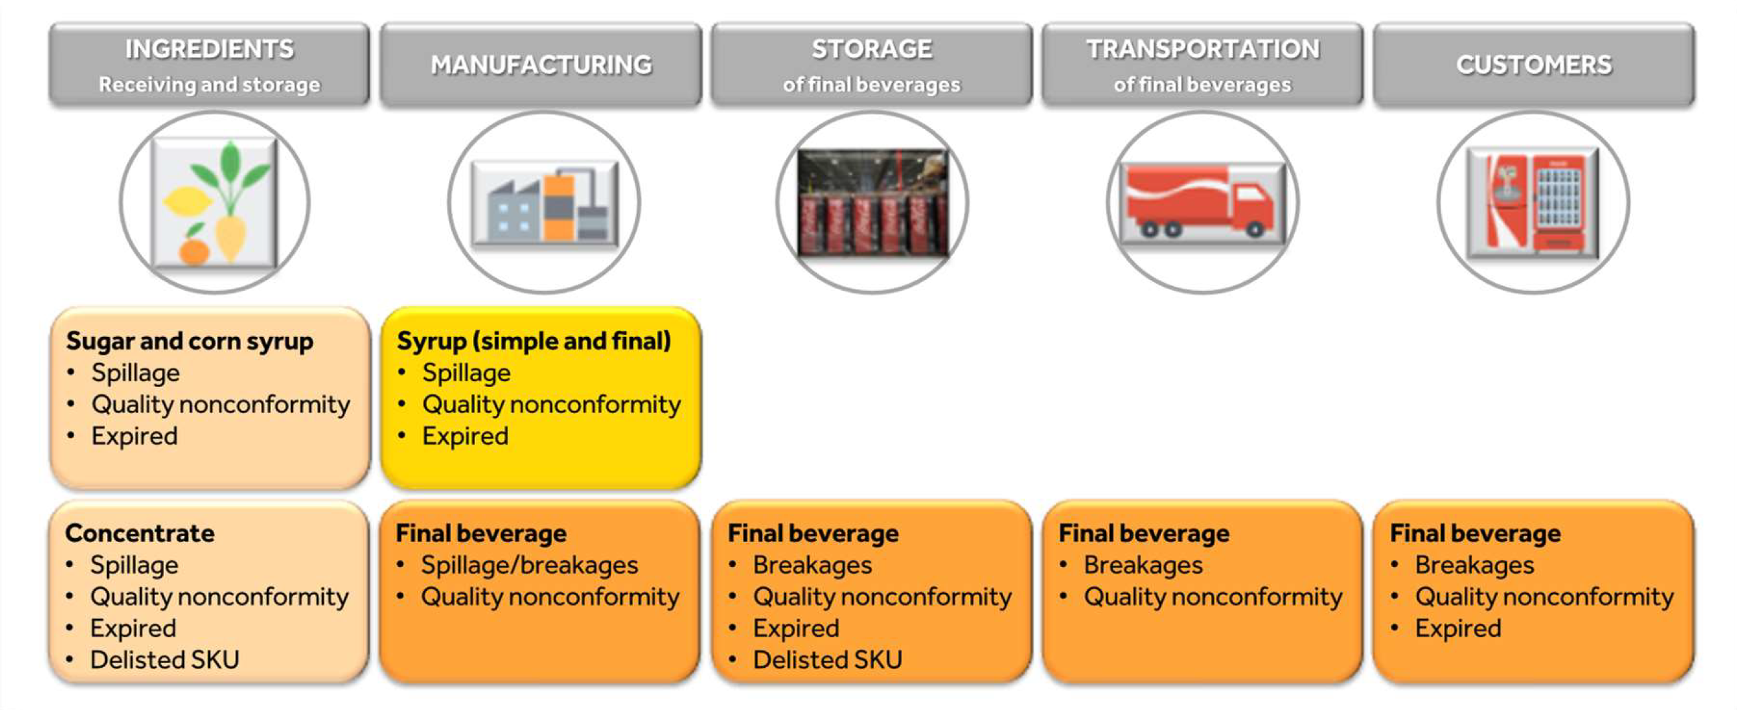
3. Actions to prevent food loss
Through operational excellence, we strive to either prevent food wastage or redirect nutrients for industrial use. Only where this is not possible, we recover the wasted parts for composting or further converting in energy. This approach safeguards that only a residual mass will be eventually disposed of.
We engage with a broad array of stakeholders for actions preventing food loss, i.e.
- Training employees to prevent food wastage and optimize production;
- Liaising with raw materials suppliers to ensure that our Sustainable Agricultural Principles and Supplier Guiding Principles are applied including that raw materials are produced to meet commercial and regulatory safety and quality standards;
- Working with supply chain partners to improve storage and transportation;
- Providing product storage instructions and freshness rules to customers as well as best-before-dates to consumers;
- Providing different serving sizes for our products to fit the needs of consumers;
- Collaborating with customers, NGOs and peers using alternative channels, such as food banks or markets, to redirect it to feed people;
- Engaging with customers to share identified best practice, pilot Zero Waste Schemes and communicate results and benefits to the wider community;
- Engaging with business partners, regulators, academia, peers, NGOs and our communities in order to identify and implement innovate solutions that help prevent food loss.
4. Reporting
As an integral part of our internal managerial reporting routines, we track the progress food loss along all relevant dimensions of the value chain (as outlined in section 2). To foster all corrective actions required i.e., prevent, and minimize food loss, we apply the Plan-Do-Check-Act cycle.
The aggregate results are discussed in the Social Responsibility Committee. We also report on our actions and progress in the annual company report.

As General Manager of the Company, I am committed to our Food Loss Policy and to ensuring successful implementation of our strategies and objectives.

Belgrade, February 2024

Svetoslav Atanasov
General Manager

